Боцан Николай P-2023R

***Индивидуальная работа за 17.02.22***

***«Учёт продажи техники в компьютерном магазине»***

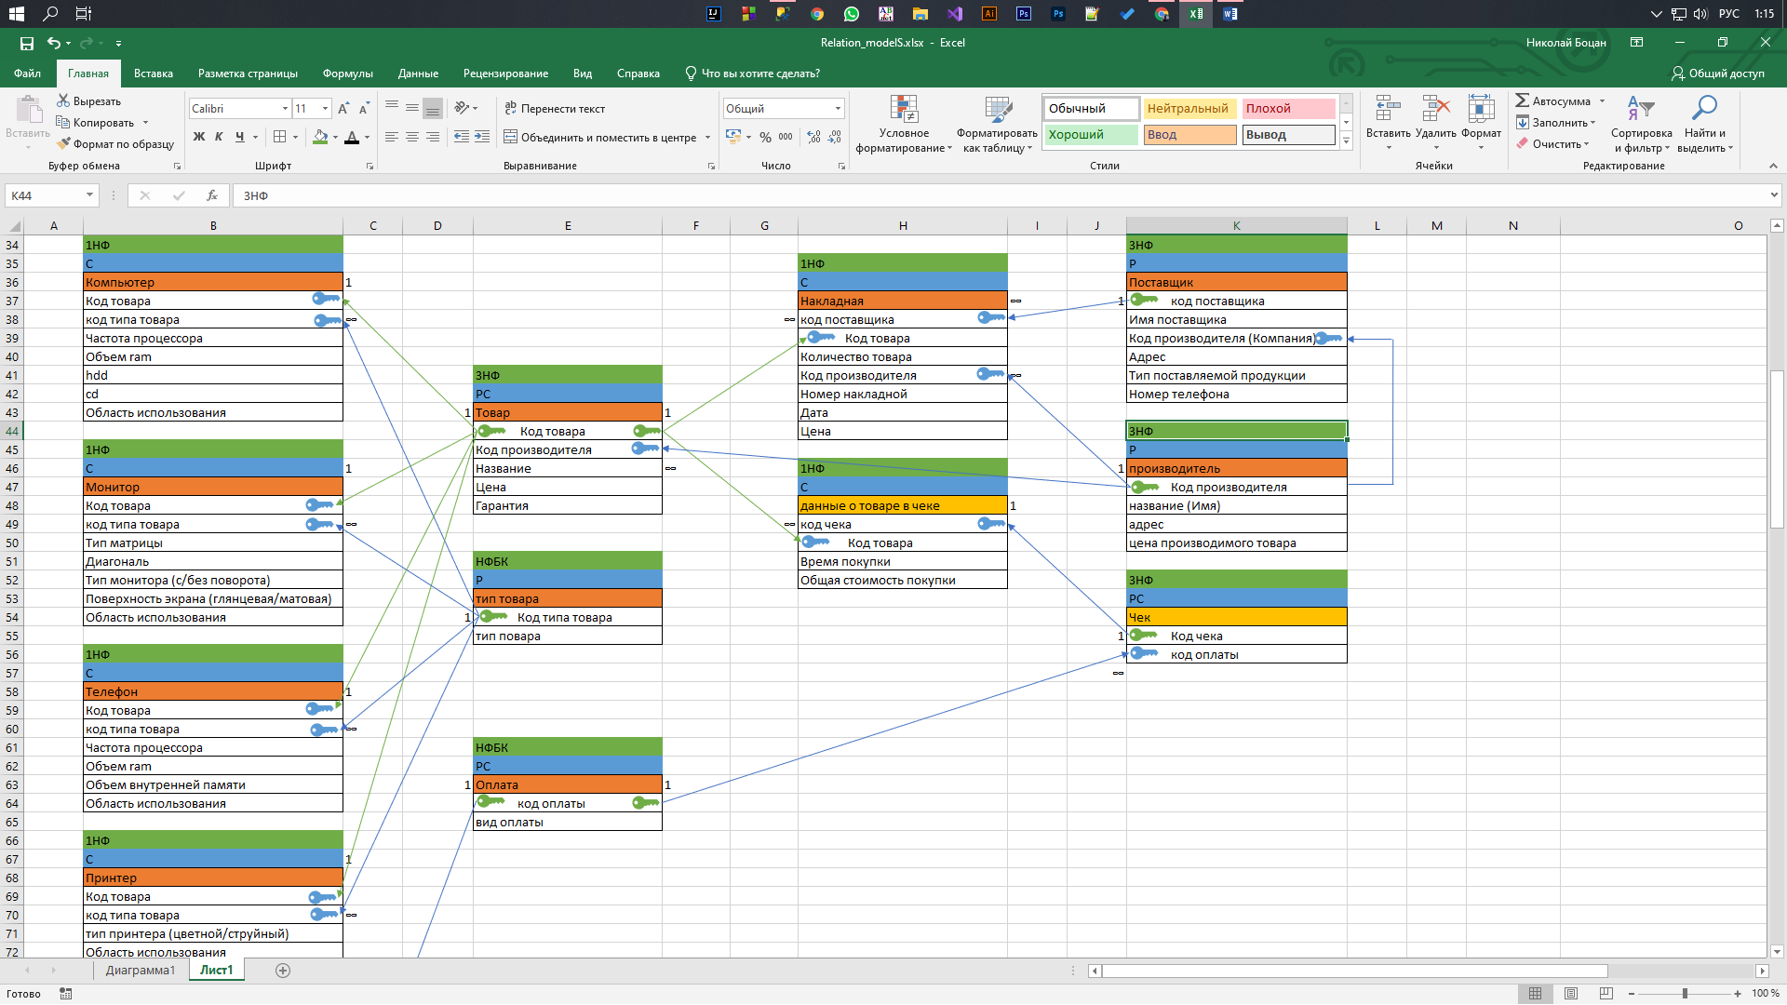**Реляционная модель:**

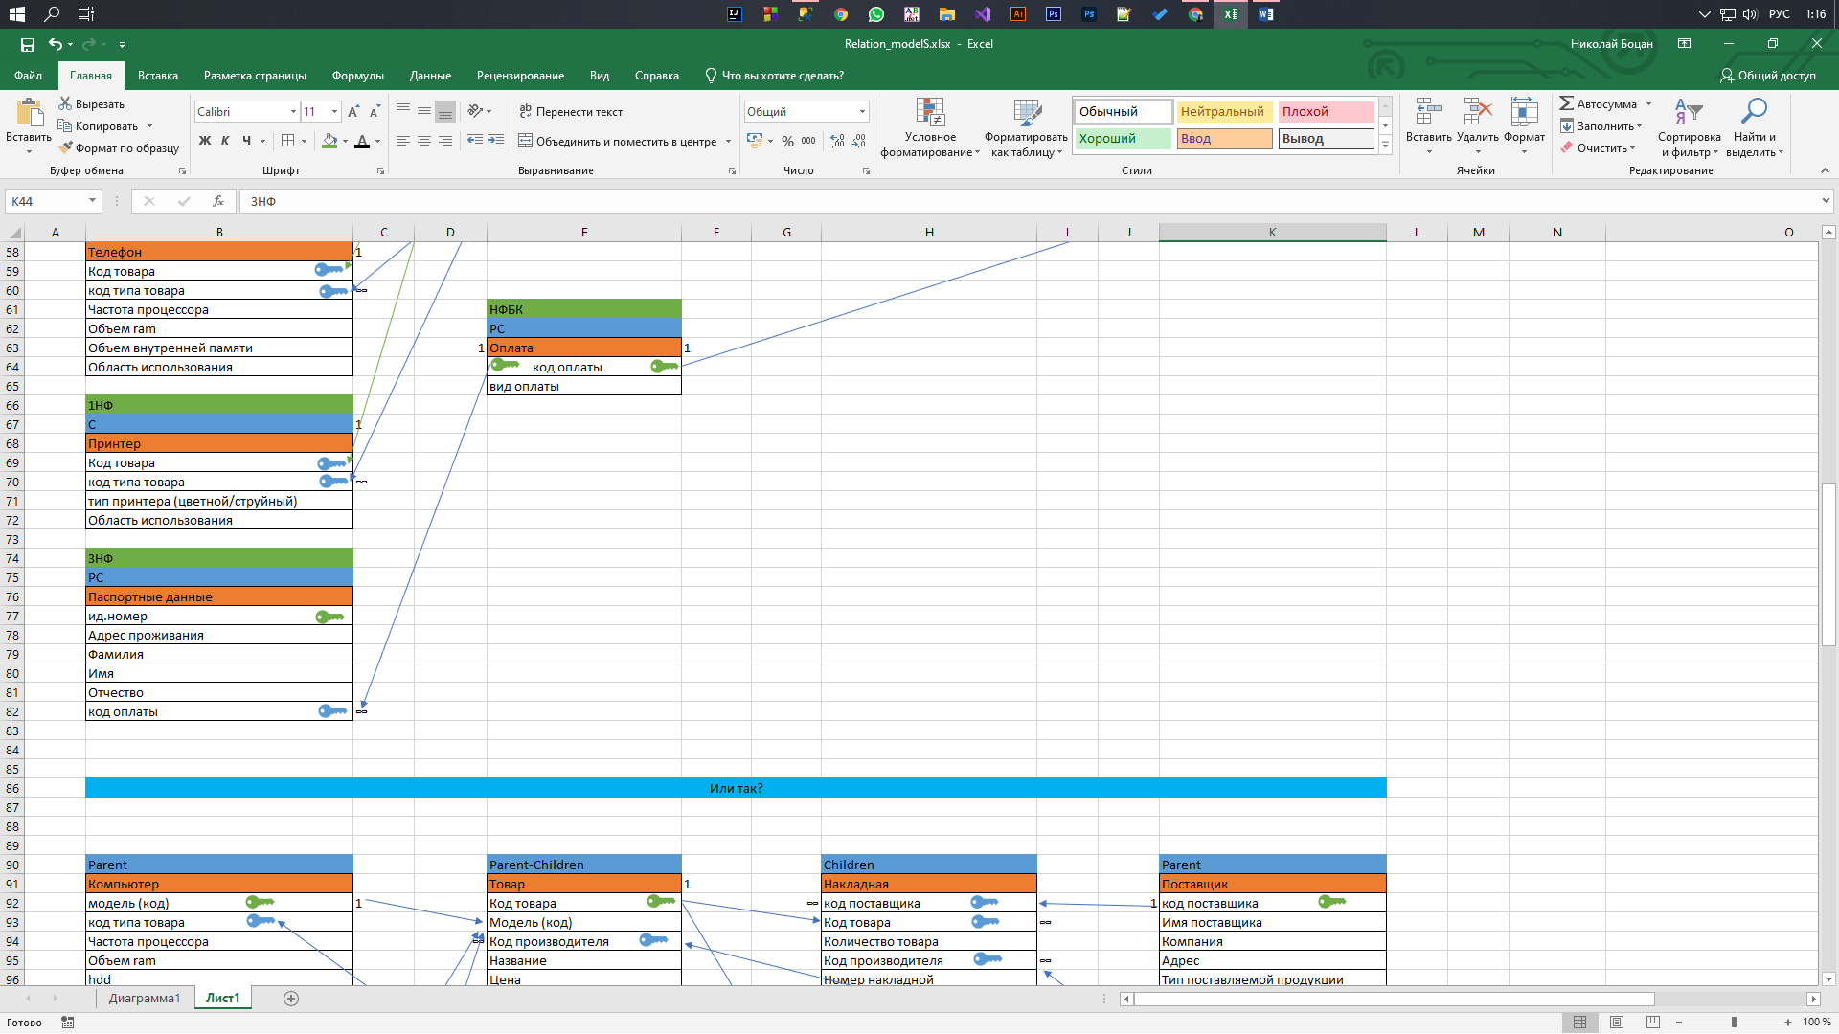



**Код:**

--Создание контейнера базы данных--

create database Computer_magazine

go

--Активизирование контейнера базы данных--

use Computer_magazine

go

--Создание пользовательских доменов--

create type Adres from *varchar*(70);

go

create type applicationS from *varchar*(100);

go

create type TNumber from *char*(12);

go

--Создание отношений базы данных--

create table *Pasport_data*(Id int primary key,

                    C_Adres Adres,

                    C_Surname *varchar*(12),

                    C_Name *varchar*(12),

                    C_FatherName *varchar*(12),

                    Pay_code int foreign key references *Payment*(Pay_code) *not* null)

go

insert into *Pasport_data*(Id, C_Adres, C_Surname, C_Name, C_FatherName, Pay_code)

values (1001, 'ул.Пушкина 6/7', 'Балконский', 'Андрей', 'Николаевич', 102),

      (1002, 'ул. Николае Милеску Спэтарул 21/1', 'Безухов', 'Пьер', 'Анатольевичь', 101),

      (1003, 'ул. Садовяну 13/5', 'Ростов', 'Николай', 'Ильич', 103),

      (1004, 'ул. Петру Заднипру 28/8', 'Болякин', 'Андрей', 'Никифорович', 102),

      (1005, 'ул. Мунчешть 76/9', 'Шишкин', 'Алескандр', 'Игоревич', 103)

go

create table *Product_type*(Cod_type smallint primary key,

                    Product_type *varchar*(20))

go

insert into *Product_type*(Cod_type, Product_type)

values (2000, 'PC'),

      (2010, 'Laptop'),

      (2020, 'Monitor'),

      (2030, 'Phone'),

      (2040, 'Tablet PC'),

      (2050, 'Printer')

go

create table *supplier*(Sup_code int primary key,

                 Sup_name *varchar*(20),

                 Company *varchar*(20),

                 Sup_Adres Adres,

                 production_type *varchar*(40))

go

alter table supplier

add Telephone TNumber

go

alter table supplier

drop column Company

go

alter table supplier

add Man_cod int foreign key references *manufacturer*(Man_code) *not* null

go

insert into *supplier*(Sup_code, Sup_name, Man_cod, Sup_Adres, production_type, Telephone)

values (3001, 'Comp_Moldova', 4003, 'ул. Штефан чел маре 21/5', 'PCs, Laptops, Monitors, Phones', '+37367354672'),

      (3002, 'Hyper Supply', 4005, 'ул. Гоголя 34/4', 'PCs, Monitors, Printers, Laptops', '+37369984519'),

      (3003, 'GMSupply', 4006, 'ул. Колумна 5', 'PCs, Laptops', '+37378534765'),

      (3004, 'TechMD', 4002, 'ул. Узинелор 7', 'Monitors, Phones, Laptops', '+37379945543'),

      (3005, 'XMoldova', 4001, 'ул. Петру Мовилэ 7', 'Laptops, Phones, Printers, Monitors', '+37360606607'),

      (3006, 'Hyper Supply', 4004, 'ул. Михаил Садовяну 3', 'PCs, Monitors, Printers', '+37369984519')

go

update supplier

set Sup_name = 'HPSupply'

where Sup_code = 3006

go

create table *manufacturer*(Man_code int primary key,

                    Man_name *varchar*(20),

                    Man_Adres Adres,

                    Man_Production_price smallint)

go

insert into *manufacturer*(Man_code, Man_name, Man_Adres, Man_Production_price)

values (4001, 'Xiaomi', 'ул. Петру Мовилэ 8', 2000),

      (4002, 'Samsung', 'ул. Узинелор 10', 3000),

      (4003, 'LG', 'ул. Мунчешть 7', 3000),

      (4004, 'HP', 'ул. Гоголя 36', 2000),

      (4005, 'Hyper PC', 'ул. Михаил Садовяну 10', 4000),

      (4006, 'Game Max', 'ул. Отовыска 7', 4000)

go

create table *Payment*(Pay_code int primary key,

                Pay_type *varchar*(15) default 'cash')

go

insert into *Payment*(Pay_code, Pay_type)

values (101, 'credit'),

      (102, 'credit card'),

      (103, 'cash')

go

create table *Chek*(Check_code int primary key,

              Pay_code int foreign key references *Payment*(Pay_code) *not* null)

go

insert into *Chek*(Check_code, Pay_code)

values (1013, 101),

      (1014, 102),

      (1017, 103),

      (1020, 103),

      (1022, 102)

go

create table *Product*(cod_prod int primary key,

                Man_cod int foreign key references *manufacturer*(Man_code) *not* null,

                Prod_name *varchar*(20),

                Price smallint,

                Waranty smallint *check*(Waranty <= 5) default 1)

go

insert into *Product*(cod_prod, Man_cod, Prod_name, Price, Waranty)

values (5000, 4005, 'Blye Yeti', 20000, 5),

      (5010, 4006, 'Nitro', 25000 ,3),

      (5020, 4003, 'Spin 5', 5000, 1),

      (5021, 4004, 'Hp one', 2000, 1),

      (5030, 4002, 'Redmi 5 pro', 4000, 1),

      (5040, 4001, 'Prestige Pro 3', 4700, 2),

      (5050, 4004, 'All Vew Pro', 2000, 3),

      (5051, 4001, 'Clear Sky', 3000, 4),

      (5052, 4001, 'Colors', 2500, 2)

go

create table *Computer*(cod_prod int foreign key references *Product*(cod_prod) unique *not* null, --связь 1 к 1--

                 Cod_type smallint foreign key references *Product_type*(Cod_type) *not* null,

                 CPU_freq smallint default 2000,

                 RAM smallint default 1000,

                 HDD smallint default 250,

                 CD *varchar*(5) *check*((CD = 'true') *or* (CD = 'false')) default 'false',

                 Applic applicationS)

go

insert into *Computer*(cod_prod, Cod_type, CPU_freq, RAM, HDD, CD, Applic)

values (5000, 2000, 4200, 16000, 1000, 'false', 'Gaming'),

      (5010, 2010, 3900, 8000, 2500, 'true', 'Gaming')

go

create table *Monitor*(cod_prod int foreign key references *Product*(cod_prod) unique *not* null,

                Cod_type smallint foreign key references *Product_type*(Cod_type) *not* null,

                Tatrix_type *varchar*(5) default 'TN',

                Diagonal smallint default 21,

                Monitor_type *varchar*(20) default 'without rotation',

                Matrix_size *varchar*(10) default 'glossy',

                Applic applicationS)

go

insert into *Monitor*(cod_prod, Cod_type, Tatrix_type, Diagonal, Monitor_type, Matrix_size, Applic)

values (5020, 2020, 'IPS', 21, 'with rotation', 'mate', 'Gaming'),

      (5021, 2020, 'TN', 18, 'without rotation', 'glossy','Office')

go

create table *Phone*(cod_prod int foreign key references *Product*(cod_prod) unique *not* null,

               Cod_type smallint foreign key references *Product_type*(Cod_type) *not* null,

               CPU_freq smallint default 1000,

               RAM smallint default 1000,

               Intern_mem smallint default 5000,

               Applic applicationS)

go

insert into *Phone*(cod_prod, Cod_type, CPU_freq, RAM, Intern_mem, Applic)

values (5030, 2030, 2000, 3000, 32000, 'Dayly'),

      (5040, 2040, 3000, 4000, 32000, 'Graphic design')

go

create table *Printer*(cod_prod int foreign key references *Product*(cod_prod) unique *not* null,

                Cod_type smallint foreign key references *Product_type*(Cod_type) *not* null,

                Printer_type *varchar*(6) *check*((Printer_type = 'color') *or* (Printer_type = 'laser')) default 'laser',

                Applic applicationS)

go

insert into *Printer*(cod_prod, Cod_type, Printer_type, Applic)

values (5050, 2050, 'laser', 'Office'),

      (5051, 2050, 'color', 'Photos'),

      (5052, 2050, 'color', 'Photos')

go

create table *consignment*(Sup_code int foreign key references *supplier*(Sup_code) *not* null,

                   cod_prod int foreign key references *Product*(cod_prod) *not* null,

                   prod_number smallint,

                   Man_code int foreign key references *manufacturer*(Man_code) *not* null,

                   consignment_number int,

                   Consignment_date date,

                   Price smallint)

go

insert into *consignment*(Sup_code, cod_prod, prod_number, Man_code, consignment_number, Consignment_date, Price)

values (3002, 5000, 5, 4005, 10456, '2021-12-21', 17000),

      (3003, 5010, 3, 4006, 10432, '2022-01-04', 14000),

      (3001, 5020, 4, 4003, 10487, '2021-10-10', 3000),

      (3006, 5021, 7, 4004, 10499, '2022-01-09', 1000),

      (3004, 5030, 10, 4002, 10444, '2022-02-27', 2500),

      (3005, 5040, 8, 4001, 10411, '2022-01-01', 3000),

      (3006, 5050, 11, 4004, 10410, '2022-02-04', 1500),

      (3005, 5051, 15, 4001, 10440, '2022-02-02', 2000),

      (3005, 5052, 12, 4001, 10404, '2021-12-13', 1700)

go

create table *Chek_infoChek*(Check_code int foreign key references *Chek*(Check_code) *not* null,

                     cod_prod int foreign key references *Product*(cod_prod) *not* null,

                     Purc_date date,

                     Gen_price smallint)

go

insert into *Chek_infoChek*(Check_code, cod_prod, Purc_date, Gen_price)

values (1013, 5000, '2021-12-31', 20000),

      (1014, 5052, '2021-12-31', 2500),

      (1017, 5040, '2022-01-08', 4700),

      (1020, 5021, '2022-01-09', 2000),

      (1022, 5030, '2022-02-28', 4000)

go

--Укажите, какая информация в созданной базе данных может изменяться и примените команды группы DML для её изменения.--

--Printer(Printer_type)--

update Printer

set Printer_type = 'laser'

where cod_prod = 5052

go

update Printer

set Printer_type = 'color'

where cod_prod = 5052

go

--Computer(RAM, HDD, CD)--

update Computer

set RAM = 32000

where (Cod_type = 2000) *and* (cod_prod = 5000)

go

update Computer

set RAM = 16000

where (Cod_type = 2000) *and* (cod_prod = 5000)

go

--Product(price, name)--

update Product

set Price = 15000

where (Prod_name = 'Blue Yeti') *and* (cod_prod = 5000)

go

update Product

set Prod_name = 'Blue Yeti'

where Prod_name = 'Blye Yeti'

go

update Product

set Price = 20000

where (Prod_name = 'Blue Yeti') *and* (cod_prod = 5000)

go

--manufacterer(Man_name, Man_Production_price)

update manufacturer

set Man_name = 'Lenovo'

where Man_name = 'HP'

go

update manufacturer

set Man_name = 'HP'

where Man_name = 'Lenovo'

go

update manufacturer

set Man_Production_price = 7000

where Man_Production_price = 2000

go

update manufacturer

set Man_Production_price = 2000

where Man_Production_price = 7000

go

select *

from manufacturer

go

--supplier(production_type, Sup_name)

update supplier

set Sup_name = 'SamsungS_MD'

where Sup_name = 'TechMD'

go

update supplier

set Sup_name = 'TechMD'

where Sup_name = 'SamsungS_MD'

go

update supplier

set production_type = 'Monitors, Phones, Laptops, PCs'

where Sup_name = 'TechMD'

go

update supplier

set production_type = 'Monitors, Phones, Laptops'

where Sup_name = 'TechMD'

go

--Создайте необходимые индексы--

/*Можно было бы создать индексы также и для отношений product_type и Payment, но в данных отношениях только два столбца, один из которых первичный ключ */

--создание индексов для отношения manufacturer (редко вносим, часто берём => index)--

create index man_name_indx on *manufacturer*(Man_name)

go

create index man_adres_indx on *manufacturer*(Man_Adres)

go

--создание индексов для отношения supplyer (редко вносим, часто берём => index)--

create index sup_name_indx on *supplier*(Sup_name)

go

create index sup_adres_indx on *supplier*(Sup_Adres)

go

create index sup_telephone_indx on *supplier*(Telephone)

go

create index sup_prodType_indx on *supplier*(production_type)

go

--Вывод содержимого отношений на экран--

/*

select *

from Product

inner join manufacturer on Product.Man_cod = manufacturer.Man_code; --Естественное соединение--

go

*/

select *

from Chek

go

select *

from Chek_infoChek

go

select *

from Computer

go

select *

from consignment

go

select *

from manufacturer

go

select *

from Monitor

go

select *

from Pasport_data

go

select *

from Payment

go

select *

from Phone

go

select *

from Printer

go

select *

from Product

go

select *

from Product_type

go

select *

from supplier

go

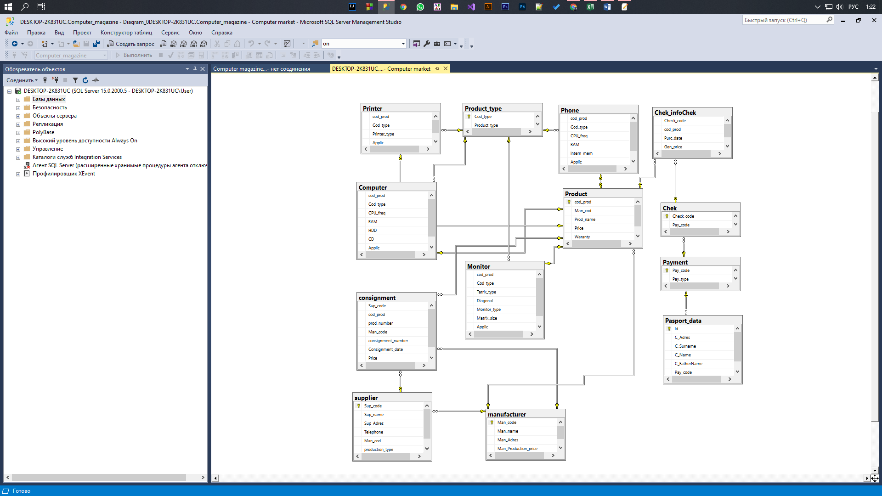**Диаграмма Базы Данных:**